

Office of Grants and Local Services

Lease Agreements and Turn-Key Projects

Handbook

May 2026

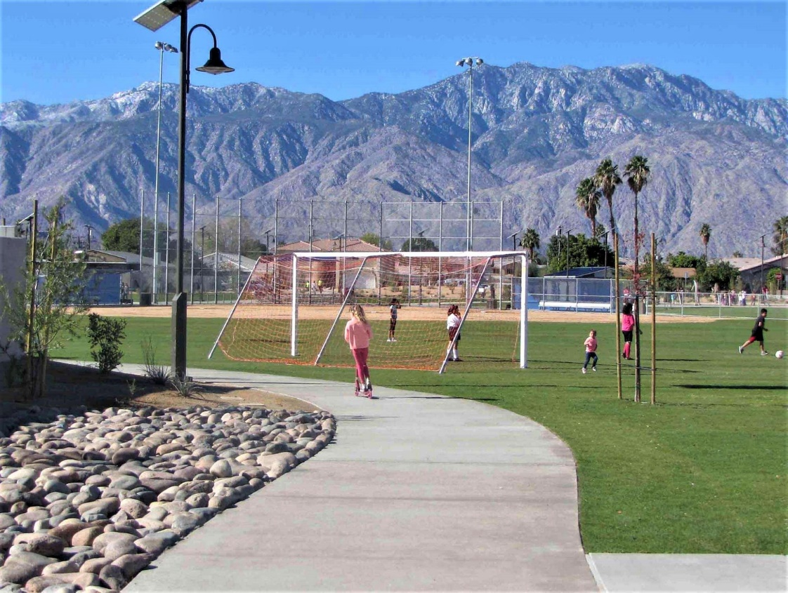

Ocotillo Wells Park, Cathedral City
Statewide Park Program

Purpose and Reference:
This handbook is referenced in the Statewide Park and Community Revitalization Program (SPP) Application Guide on page XX – Checklist Item #10: Project Site Ownership, Acquisition, or Lease. Discussed under #3 and #4 of Checklist Item #10, this handbook provides instructions for Lease and Turn-Key Agreements.

All words in small caps are defined in the SPP Application Guide.

- This document is only for lease agreements or turn-key projects on land not owned by the applicant.
- Ignore this document if the applicant already owns the land or is proposing an acquisition to become the landowner.

3. Lease Agreements - page XX of the SPP Application Guide:
Lease agreements are completed when an applicant is proposing to construct, operate and maintain a project on land owned by a separate public agency or utility district.

If if the grant is awarded, the applicant/grantee would complete the project and operate and maintain the project for public use for the 30-year contract performance period. See pages XX through XX below for instructions.

4. Turn-Key Agreements - page XX of the SPP Application Guide:
Turn-Key agreements occur when an applicant is proposing to construct a project, and upon project completion, and with approval by the State, transfer the project and contract obligations to the landowner. The landowner would then become responsible for the operation and maintenance of the project for public use during the remainder of 30-year contract performance period. See page XX below for instructions

These alternative requirements to site ownership give the grantee, State, and public assurance that the property will be used for the purpose of the grant.

LEASE AGREEMENT

XX on page XX of the FINAL SPP Application Guide – Month Date, 2026

In this alternative to land ownership by the applicant, the landowner is giving the applicant permission to construct, operate and maintain the project during the 30- year contract performance period. The 30 years start with the appropriation date.

Applicants should include A and B in the application:
- Provide the Lease Agreement Form (see next page). The form lists the land tenure agreement requirements between the applicant and the landowner.

- Provide a signed copy of the agreement between the applicant and the landowner. This can be the lease, joint powers agreement, easement, memorandum of understanding, etc.
  - On the signed copy, highlight the sections that meet the requirements listed in the Lease Agreement Form.

Draft/Unsigned agreements:
If the agreement cannot be signed at the time of application, provide A and B as explained above with a letter(s) from the applicant signed by the authorized representative and the landowner in which each commits to sign the land tenure agreement should the grant be awarded. If the grant is awarded, the applicant and landowner must sign the land tenure before the contract can be signed by the California Department of Parks and Recreation (DPR).

When the Public Agency/Utility cannot agree to a 30-year term requirement:
If the Public Agency/Utility has a policy prohibiting 30-year term agreements, the applicant should provide the following:

- A and B, as explained above
- a letter(s) from the landowner and applicant that:
  - States the landowner’s policy prohibiting long term land tenure agreements.
  - Describes the past long-standing use (or likelihood of long-term use) of the property by the applicant
  - States the landowner’s commitment to renew the land tenure agreement with the applicant in incremental periods to satisfy 30-year land tenure term requirement, absent any unforeseen circumstances.
  - The letter must be signed by signed by the authorized representative and the landowner.

DPR expects the grantee to fully comply with the Use of Facilities terms of the contract. The grant administration guide, contract and its provisions are available under grant administration at www.parks.ca.gov/spp.

If the landlord does not renew a lease, and the grantee cannot comply with the tenure period stated in the contract, DPR may hold the grantee in breach of contract.

Frequently Asked Questions about the Lease Agreement Form
- If the applicant owns the property, is the Lease Agreement Form required?
No. It is only required if the property is leased from a landowner.
- If the applicant will be acquiring the property to become the landowner, is the Lease Agreement Form required?
No. For acquisition projects, see item #2 on page XX of the Application Guide.
- Operation Partnerships: If a city receives a grant award, could the city give operational site control to a nonprofit that will provide recreation and other community services on the project site?
nonprofits or other entities can partner with a grantee to provide recreational and other community services. However, the grantee is responsible for overseeing long-term project operations to ensure that the grant contract obligations are met. The project must remain open to the public when a nonprofit or other entity operates the site.
- Can one city entity apply for an acquisition and development OR development only project, receive a grant award, complete the project, AND then transfer the grant contract obligations to another entity of the same city?
At the time of application, the applicant must provide an authorizing resolution using the template in the application guide.
- The applicant must include the following verbiage: “Note: (City Entity A) is the applicant/grantee, and (City Entity B) will assume the transfer of the contract obligations as described below.”
- The applicant must add language to the authorizing resolution establishing its intent for “City Entity A” to transfer the contract obligations to “City Entity B” upon successful completion of the project, should the grant be awarded.
- The authorizing resolution must include language specifying that if the grant is awarded, “City Entity A” as the grantee must comply with the contract provisions through project completion for 30 years, or until the State approves the transfer of the contract obligations to the “City Entity B”, whichever is earlier.
OGALS’ requirements ensure that the continuity of the contract obligations will be maintained for the benefit of the public if a competitive grant is awarded.

Note: The above arrangement may be discussed in the applicant’s response to Checklist Item #9 - Applicant Capacity on page XX of the Application Guide.

TURN KEY AGREEMENT

XX on page XX of the FINAL SPP Application Guide – Month Date, 2026

A turn-key project is when the applicant proposes to complete the project with the intent to transfer the project and contract obligations to an eligible agency for long term operation and maintenance.
The transferee must meet these requirements:

- Be an eligible public agency: City, County, joint powers authority, or district as defined in the Application Guide.

- Must be, or will become, the landowner.

- Must be willing to accept and enter into a contract with DPR. This includes being responsible for long-term public use (operation and maintenance).

Provide all three documents in the application:

- Authorizing Resolution from the applicant: Provide A and B below in the resolution. Refer to pages XX-XX of the SPP Application Guide for information on the resolution.
  - State the intent to transfer the project and contract obligations to the transferee (Eligible City, County, joint powers authority, or district) upon successful completion of the project, should the grant be awarded.
  - The applicant’s agency, not transferee, acknowledges that it will comply with the contract provisions until the State approves the transfer of the contract obligations to the transferee.

- Authorizing Resolution from the transferee: The transferee will provide a separate resolution with the addition of A below. Refer to pages XX-XX of the SPP Application Guide for information on the resolution.
  - State the intent to accept the project and contract obligations from the _______(name of the applicant not transferee) upon successful completion of the project and the California Department of Parks and Recreation (DPR) approval of the transfer, should the grant be awarded.

- A Turn-Key Agreement between the applicant and the Transferee that is signed by both parties. The agreement must include the stipulations shown in A and B below.
  - The project and grant contract obligations will be transferred from the (applicant/grantee) to the (transferee) upon project completion and approval of the transfer by the DPR.
  - If the grant is awarded, the applicant/grantee must comply with the contract provisions through project completion for 30 years, or until DPR approves the transfer of the contract obligations to the transferee, whichever is earlier.

These requirements ensure that the continuity of the contract obligations will be maintained for the benefit of the public if a competitive grant is awarded.

